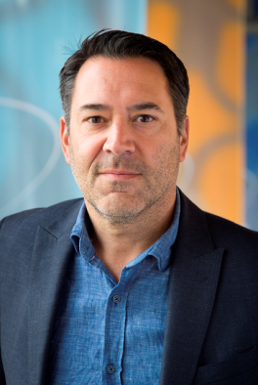

Drs. G.L.A. Ubachs
George Ubachs is Managing Director of EADTU, the European Association of Distance Teaching Universities. EADTU is Europe's institutional association of leading universities in online, open and flexible higher education, and is at the heart of the modernisation agenda of European universities. Growing from its eleven founding members in ten European nations, EADTU now has a membership of fifteen institutions and fourteen national associations across 25 nations. Its membership covers over 200 universities and around 3 million students.

George Ubachs is responsible for the development and support of the EADTU network, policies and execution of its goals in online, open and flexible higher education.
He is coordinator of international academic cooperation networks on networked curricula, virtual mobility, QA in online education and on business models for lifelong learning.
George Ubachs is coordinator of the E-xcellence movement on quality assurance in online, open and flexible education and leading the ICDE-UNESCO focal point for QA in online education in Europe. He further coordinates the EMPOWERing universities network of a 100 experts that represent 12 specific fields of expertise related to online, open and flexible education. As coordinator of these two dedicated networks he is working closely with the EUA, ENQA, ESU, ICDE and Unesco.
Before joining EADTU in 2002, George Ubachs has been working on various European programmes in the public and private sector in the field of regional social economic developments and was coordinator of the European Network of E2C-Europe (Cities for Second Chance Schools). George Ubachs graduated at State University of Leiden and Erasmus University Rotterdam on Public Administration with specialization in European Integration.

Main links to EADTU and running programmes:
-http://www.eadtu.eu/
-http://empower.eadtu.eu/
-http://www.openuped.eu/
-http://e-xcellencelabel.eadtu.eu/

